Air Sail

Subject:  Related Subjects: | Grade Level(s):  Length of Lesson: | Type: Inquiry / Design / Project  Keywords:

Lesson Overview
The vehicle will be mounted on two straws through with the string will pass through. The string will be 6” apart and 12” off the ground. The only source of power allowed will be a standard box fan. Each group will create a launch platform from 1⁄4” dowels, wood skewers and balsawood. Launch platform must be 12” from the ground in all parts.

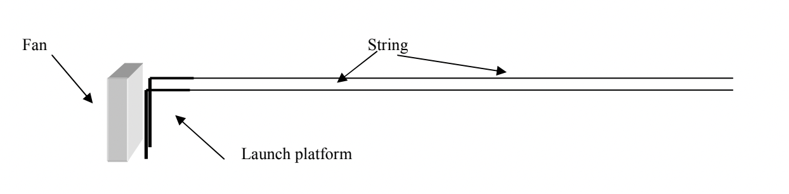

Lesson Focus
Each group will create a vehicle that travels down two parallel pieces of string.

Lesson Objective(s) | By the end of this lesson, students will…  - Learn the concepts of attraction, repulsion, friction, polarity, and charge.

Lesson Timing

5 minutes | Introduce the Lesson
30 minutes | ...

Materials | - 1. Box fan  - 2. String  - 3. Straws  - 4. Foam board  - 5. Card stock  - 6. Paper  - 7. Plastic  - 8. Toothpicks  - 9. Wood skewers  - 10.Tape  - 11.Hot Glue Gun  - 12.Glue sticks
Instructor Prep | - Step 1
Related Resources | - List related lessons/ppts etc available from USC or outside, trusted orgs

Lesson Plan

Introduction
Introduce students to the learning goals and make connections to past and present learning experiences. Stimulate interest and prompt students to identify their own questions about the topic. This can link the lesson to real world examples, introduce associated STEM careers, and assess their prior knowledge on the topic.

- Step 1

Procedure
List the steps of the activity. Remember to focus on leading students to the solution, rather than just telling them what to do. Include pictures of steps if you have them. Be sure to include some steps for discussion and reflection.

- Step 1

Wrap-up
End the lesson with some final discussions about what students designed/discovered. Connect their activity back to the focus question/problem, real world examples, and STEM careers.

Also include notes about any special cleanup considerations

Lesson Background for Teachers

Suggested Real-World STEM Connections
- List possible related Role Models in STEM (with details and links to more reading). Give suggestions for examples of scientists/engineers who are from underrepresented groups in STEM in related careers.
- List related real-world engineering problems and examples

Lesson Variations and Options
Include descriptions of alternative methods or ways to present things.

Explanation
Describe the background concepts and explanations behind the lesson. This can be more in depth than a teacher/instructor would actually share with students.

Key Concepts and Vocabulary
- Word 1: Grade Appropriate Definition
- Word 2: Grade Appropriate Definition

Safety Notes
- Safety instruction

